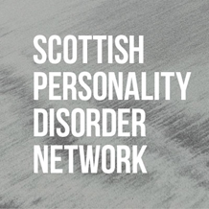
Scottish ‘Personality Disorder’* Network Conference
at Abertay University Dundee, 26th June 2024:
Submission Proposal

*inverted commas are used to acknowledge the debate and broad range of views around these diagnoses.

Thank you for considering sharing your ideas and perspective at our 2024 conference. You can consider inputting to the conference in any way, whether that be a formal presentation, or a more creative means of communicating ideas. We will accept submissions of posters, workshops, presentations, storytelling and any artistic expression.

Name and contact details:
Title of submission:
Type of submission:
Preferred length of submission*:
Please delete as appropriate:
0-10 minutes
10-20 minutes
20-30 minutes
30-40 minutes
*please note you may be asked to present a shorter submission depending on conference programme.

Description of submission (300 words maximum):
Why do you think this is important to share with our network?

Please submit this completed form to: aidan.mitchell@changemh.org by the end of Monday 13th May.

Anyone who submits an abstract should also register to attend the conference on this link.

